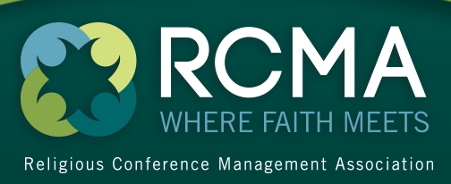

Penton Media
249 W. 17th Street, 4th Floor
New York, NY 10011-5300
Tel: (212) 204-4200
www.SpecialEvents.com
FIELD SERVED
RELIGIOUS CONFERENCE MANAGER serves individuals involved in the religious meeting industry.

DEFINITION OF RECIPIENT QUALIFICATION
Qualified recipients are members of the Religious Conference Managers Association, prospect members and other titled and non-titled personnel.

Official Publication of: Religious Conference Management Association
Established: 1990
Issues Per Year: 6

Analysis of Contacts by Business and Industry
BUSINESS AND INDUSTRY | Magazine
Members of the Religious Conference Managers Association, prospect members and others allied to the field | 2612
TOTAL | 2612

Online Advertising Opportunities:

Religious Conference Manager Extra E-newsletter
On the 2nd Wednesday of every month, 1,500 RCMA planner members are emailed Religious Conference Manager Extra, an e-newsletter packed with information on the religious conference meeting industry. Religious Conference Manager Extra is the official e-newsletter of Religious Conference Management Association.

